**Group Members:**

1. **Ayema Haris 01-134222-033**
2. **Hamza Afzal 01-134222-060**
3. **Muhammad Abdullah 01-134222-086**
4. **Taha Ali 01-134222-153**

**Compilation Steps:**

**Step 1 :  
Note :**

First move the project to your desktop and using cmd go inside the project now

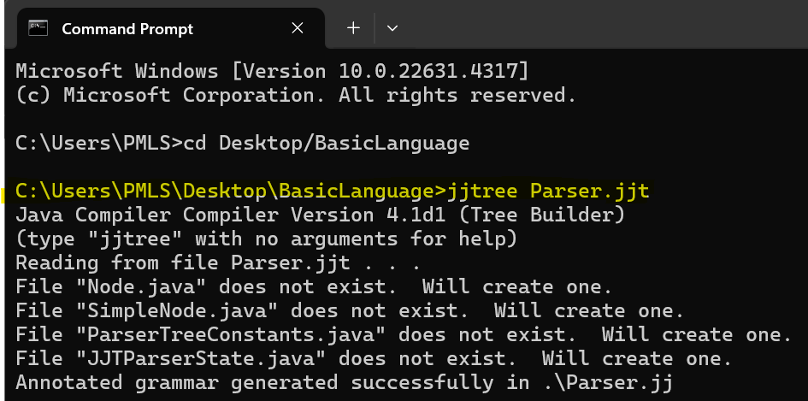

**Step 2:**

**Step 3:**

**Step 4:**

